**MINI PROJECT(M.TECH 3RD SEM- MBI2020002)**

**AVIK ATTA**

**TOPIC:- INHIBITION OF PROTEINS TO FACILITATE NERVE REGENERATION AFTER INJURY**

* **INTRODUCTION-**

[Nerve repair](https://www.sciencedirect.com/topics/medicine-and-dentistry/nerve-regeneration) is a complex [biological process](https://www.sciencedirect.com/topics/medicine-and-dentistry/biological-phenomena-and-functions-concerning-the-entire-organism) that begins almost immediately following nerve injury. The barriers to successful spontaneous [nerve repair](https://www.sciencedirect.com/topics/medicine-and-dentistry/nerve-regeneration) are manifold and in many cases surgical intervention will be necessary to ensure that functional recovery will be possible. Peripheral nerve regeneration involves complex interactions among the nerve cell body, the proximal and distal axon stumps, and neurotropic, neurite promoting (NPF), and matrix factors. Soon after nerve injury, the neuronal cell body in the spinal cord becomes swollen, the Nissl bodies start to degenerate (chromate lysis), and the nucleus moves to the periphery in preparation for changing the metabolic priority from neurotransmitter synthesis to the production of materials required for axonal growth and elongation. The cell must synthesize new messenger RNA, lipids, and proteins, especially cytoskeletal proteins such as tubulin and actin, neuro filaments, and gap-associated proteins (GAPs). GAPs, which are required to promote regeneration, are transported quickly to the distal end, at a rate of 400 mm per day. Synthesis of these proteins is 20 to 100 times higher during the early stages of regeneration than during normal growth.( J.A. Ellis, ... C.J. Winfree, in [Encyclopedia of the Neurological Sciences (Second Edition)](https://www.sciencedirect.com/referencework/9780123851581/encyclopedia-of-the-neurological-sciences))

* **NERVE REGENERATION WITH THE HELP OF SOME PROTEIN-**

A particular protein may help damaged nerves grow back after injury by blocking other proteins that hamper the recovery process. A new study shows that the protein fragment or peptide, known as NEP1-40, promoted nerve regrowth in rats with damaged spine and [brain](https://www.webmd.com/brain/picture-of-the-brain) cells. According to the study, a protein called Nogo-66, present on cells in the [brain](https://www.webmd.com/brain/rm-quiz-amazing-brain) and spinal cord, prevents nerve-cell regrowth after traumatic injury .But researchers have now identified another protein fragment (NEP1-40) that works as an antagonist to counter Nogo-66. The researchers were able to start the recovery process in laboratory rats whose spinal cords were damaged.

* **INHIBITORY ACTION OF( NOGO, OMgp, MAG PROTEINS ) IN NERVE REGENERATION-**

The inhibitory activity of Nogo proteins was first characterized by Schwab and his colleagues via size fractionation of adult central nervous system (CNS). The membrane-associated proteins NI-35/NI-250 were both potent inhibitors of [neurite outgrowth](https://www.sciencedirect.com/topics/neuroscience/neurite-outgrowth). Finally, a cDNA encoding NI-250, termed Nogo-66 (Nogo-A), was simultaneously identified to inhibit neuronal growth. Three different variants for Nogo were reported, including Nogo-A, Nogo-B, and Nogo-C, which share a common [carboxyl terminus](https://www.sciencedirect.com/topics/neuroscience/c-terminus) of 188 amino acids. The longest isoform is Nogo-A is mainly expressed in [oligodendrocytes](https://www.sciencedirect.com/topics/neuroscience/oligodendrocyte) and minimally in peripheral myelinating cells. Nogo-A mainly do axonal growth inhibition specifically in the CNS. All three Nogo isoforms contain two putative transmembrane domains. Nogo-A, the loop between the two transmembrane domains, exists partly in the extracellular surface and has [neurite](https://www.sciencedirect.com/topics/neuroscience/neurite) growth-inhibitory effects. Nogo-A binds to its receptor, NgR1, which transduces its inhibitory activity via its coreceptor molecules. Nogo-A expression was increased in the cortical neurons and anti-Nogo-A antibody improves functional recovery in adult rats after stroke. Nogo-A plays a role in the maintenance of inhibitory synapses in cerebellar [Purkinje cells](https://www.sciencedirect.com/topics/neuroscience/purkinje-cell)  and [motor neurons](https://www.sciencedirect.com/topics/neuroscience/motor-neuron) .

Unlike Nogo-A, MAG is in glia (**non-neuronal cells** in the central nervous system brain and spinal cord and the peripheral nervous system that do not produce electrical impulses. They maintain homeostasis, form myelin in the peripheral nervous system, and provide support and protection for neurons) of the CNS and [peripheral nerves](https://www.sciencedirect.com/topics/neuroscience/peripheral-nerve) but is not expressed in neuron.

OMgp was first identified as a [myelin protein](https://www.sciencedirect.com/topics/neuroscience/myelin-protein) but has subsequently been found to be expressed on some neurons in the CNS. Oligodendrocyte myelin glycoprotein (OMgp) is a glycosylphosphatidylinositol (GPI)-anchored CNS myelin protein that can inhibit neurite outgrowth. OMgp was expressed only in the inner plexiform layer in the retina and showed no change under elevated IOP. OMgp plays a role in mediating the oligodendrocyte-oligodendrocyte and oligodendrocyte-axonal membrane interactions at the nodes of Ranvier.

* **FLOWCHART OF THESE INHIBITORY PROTEIN AND THEIR PATHWAY-**

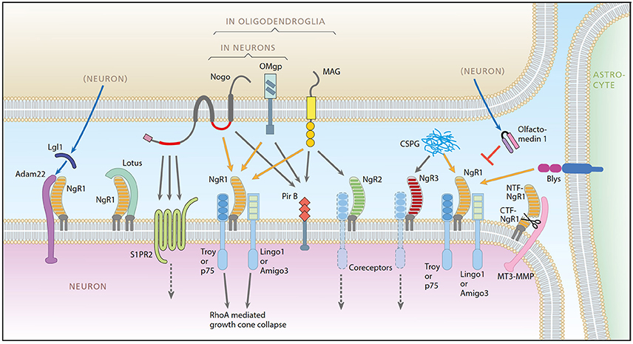

* Axon regeneration in the injured adult CNS is reportedly inhibited by myelin-derived inhibitory molecules, after binding to a receptor complex comprised of the Nogo-66 receptor (NgR1) and two transmembrane co-receptors p75/TROY and LINGO-1. However, the post-injury expression pattern for LINGO-1 is inconsistent with its proposed function. We demonstrated that AMIGO3 levels were significantly higher acutely than those of LINGO-1 in dorsal column lesions and reduced in models of dorsal root ganglion neuron (DRGN) axon regeneration. Similarly, AMIGO3 levels were raised in the retina immediately after optic nerve crush, whilst levels were suppressed in regenerating optic nerves, induced by intravitreal peripheral nerve implantation. AMIGO3 interacted functionally with NgR1-p75/TROY in non-neuronal cells and in brain lysates, mediating RhoA activation in response to CNS myelin.

Synapse development is coordinated by a number of transmembrane and secreted proteins that come together to form synaptic organizing complexes. Here, we demonstrate that leucine-rich, glioma-inactivated protein 1 (LGI1), a secreted protein previously shown to modulate synaptic AMPA receptors, is a paracrine signal released from pre- and postsynaptic neurons that acts specifically through a disintegrin and metalloproteinase protein22 (ADAM22) to set postsynaptic strength.

* LOTUS, a potent blocker of Nogo receptor-1 causing inhibition of axonal growth.

# The Sphingolipid Receptor S1PR2 Is a Receptor for Nogo-A Repressing Synaptic Plasticity(Synaptic plasticity controls how effectively two neurons communicate with each other).

# PirB is a functional receptor for myelin inhibitors of axonal regeneration.

# In the adult mammalian CNS, chondroitin sulfate proteoglycans (CSPGs) and myelin-associated inhibitors (MAIs) stabilize neuronal structure and we found that NgR1 and NgR3 bind with high affinity to the glycosaminoglycan moiety of proteoglycans and participate in CSPG inhibition in cultured neurons.

# Matrix metalloproteinases (MMPs) constitute a family of zinc-dependent endopeptidases that mediate extracellular matrix turnover and associated processes, such as cell survival, growth, and differentiation.

# B lymphocyte stimulator (BLyS), a tumor necrosis factor family protein essential for B cell development, was previously shown to be expressed at an elevated level in the CNS of multiple sclerosis patients. BLyS may be a negative regulator for neuronal functions. BLyS, which Here Nogo-66 receptor (NgR) is identified as a high affinity receptor for inhibits dorsal root ganglion outgrowth in culture. The inhibition by BLyS can be reversed by a truncated NgR or by removal of glycosylphosphatidylinositol-linked proteins from neurons.

**SIGNALING CASCADE-**

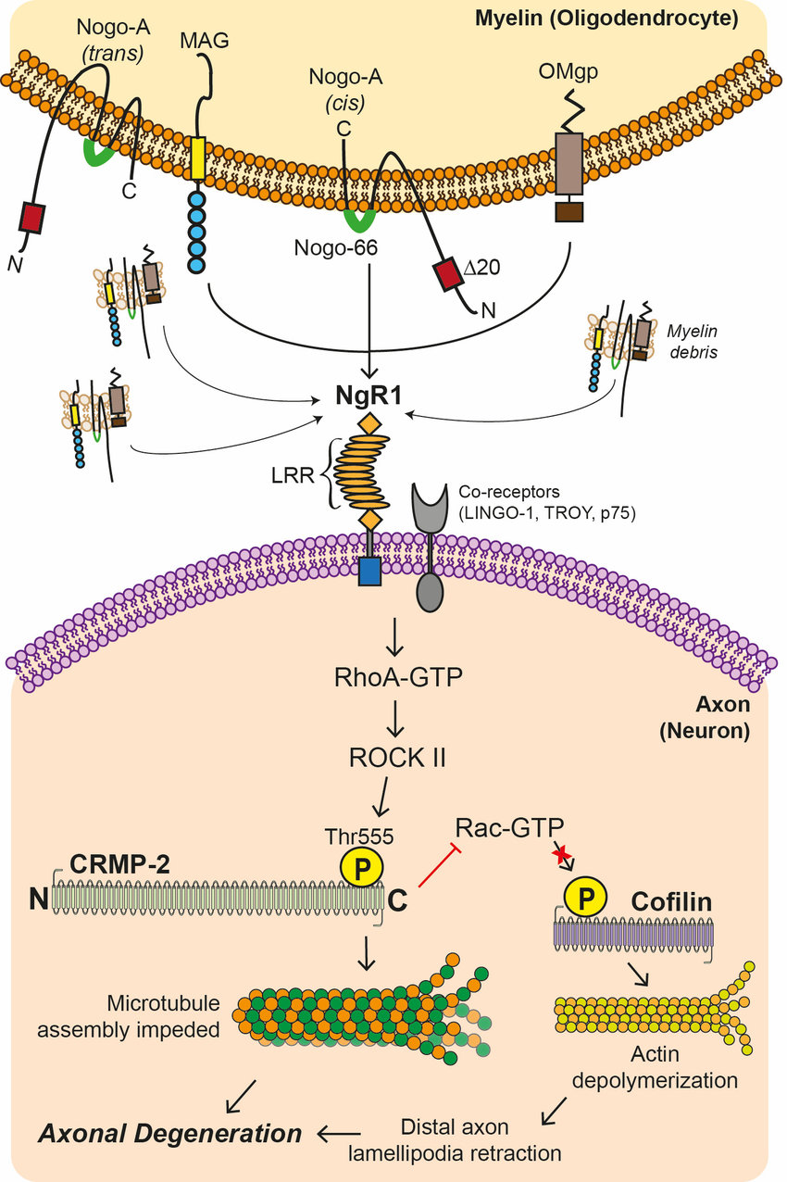

* **IDENTIFY DOMAIN OF PROTEIN WHICH INTERACT DIRECTLY IN THIS PATHWAY AND INHIBITORY LIGAND FOR THE DOMAIN**

Signal sequence of NgR1 is followed by 8 LRR domain and c terminus cysteine rich domain and GPI anchored localizing NGR to lipid rafts. Nogo A has C terminus 2 transmembrane domain and N terminal extracellular domain. Nogo 66 and PIR B causes inhibition of axonal outgrowth.

HTS and functional assay based on biochemical property shows that a molecule YU-NR-008 inhibit binding of Nogo-66 to Ngr1 and plays a role of disinhibiting axonal regeneration in neural injury.

Our goal was to employ small molecule antagonists of receptors known to be important for the purpose of regeneration of injured axons. Specifically, we hypothesized that application of a small molecule (YU-NR-008) enhances/disinhibits axonal regeneration via an NgR1-mediated mechanism in a functionally significant manner. Our intent was to utilize a small molecule inhibitor for the pharmacologic inhibition of NgR1 towards these specific aims: Observe in vitro disinhibition of axonal regeneration and functional recovery.

Application of the LPA1 antagonist AM095 would rescue LPA-mediated inhibition if AM095 were applied after the inflammatory cascade had begun in an attempt to isolate the neuro regenerative effects of AM095. LPA has been directly implicated in activating growth cone collapse via the RhoA/ROCK pathway. This pathway leads to the phosphorylation and thus inactivation of the myosin light chain phosphatase, thus allowing for the myosin II/actin network to contract. A recent experiment showed that LPA also exerts its demyelinating effects through the RhoA/ROCK pathway, at least in the PNS.

**whether there is any small molecule ligand which specifically inhibits that protein or binds to that domain of the protein which is involved in the signalling pathway**

* Olfm1(olfactomedin 1) may be used to facilitate neuronal growth after axonal damage. Olfm1 is a novel NgR1 ligand that modulates the functions of the NgR1 complex in axonal growth. Olfm1 binds to NgR1, and its binding reduced binding of NgR1 coreceptors p75NTR and LINGO-1. The Olfm1 protein contains an N-terminal signal peptide followed by a coiled-coil domain and an olfactomedin domain located in the C-terminal part of the protein molecule.

Olfm1 can regulate of axon growth through the NgR1 complex and RhoA signaling. Ligands such as MAG on the glial surface soluble molecules in the extracellular space (center compartment) bind to NgR1-p75NTR-LINGO-1 complex on the surface of the axonal growth cone (upper compartment). The signal is transduced to the intracellular space of the growth cone, converts RhoA to the active GTP-bound form, activates a cascade of proteins including ROCK and LIMK, and removes G-actin from cofilin. The released cofilin depolymerizes actin filaments, leading to growth cone collapse . When Olfm1 is secreted from the tips of the growth cone or neighboring cells, it binds to NgR1, dissociates NgR1-coreceptor interactions, and inhibits the activation of RhoA. This facilitates axon growth and may stimulate regeneration of damaged nerves.

* Nogo proteins, myelin-associated glycoprotein (MAG), oligodendrocyte myelin glycoprotein (OMgp) and B lymphocyte stimulator (BLyS), are 4 inhibitors that commonly interact with the neuronal receptor, Nogo receptor-1 (NgR1), leading to inhibition of axonal growth. Lateral olfactory tract usher substance (LOTUS) binds to NgR1 and blocks the binding of all four ligands to NgR1, resulting in the suppression of axonal growth inhibition induced by these NgR1 ligands. LOTUS allows neurons to overcome NgR1-mediated axonal growth inhibition, raising the possibility that LOTUS may be useful in future therapeutic approaches as an endogenous potent inhibitor of NgR1 for promoting neuronal regeneration.

 Overexpression of LOTUS with NgR1 in COS7 cells blocked the binding of these three NgR1 ligands to NgR1. In cultured dorsal root ganglion neurons where endogenous LOTUS is only weakly expressed, LOTUS overexpression suppressed the growth cone collapse and neurite outgrowth inhibition normally induced by these NgR1 ligands. Collectively data suggest that LOTUS suppresses NgR1-mediated axonal growth inhibition by blocking the interaction of NgR1 with its four ligands. Recently, chondroitin sulfate proteoglycans, which are abundant in reactive astrocytes derived from glial scars, have been identified as a functional ligand for NgR1 and Nogo receptor-3, an NgR1 homologue (Dickendesher et al., 2012).

 LOTUS is also able to inhibit chondroitin sulfate proteoglycans-mediated activation of NgR1 and can also suppress chondroitin sulfate proteoglycans-binding to NgR1 and chondroitin sulfate proteoglycans-induced axonal growth inhibition as shown for the other four ligands. The carboxyl-terminal region of LOTUS antagonizes NgR1 activation by Nogo66 (Kurihara et al., 2012). It will be interesting to explore whether this region would exert similar antagonistic effects on NgR1 with regards to MAG, OMgp and BLyS and which region of LOTUS is necessary and sufficient to exert the antagonistic activity on NgR1 with regards to all of the four ligands. LOTUS can completely block the interaction of NgR1 with all four ligands and therefore LOTUS can completely shut down NgR1-mediated axonal growth inhibition.

* **LIST OF MEDICINE FOR NEURODEGENERATIVE DISEASE- DRUG REPURPOSING**

Drug repositioning or repurposing is **intended to find alternative uses for a pioneering drug or a drug that is made by another innovator**. Drug repositioning is expanding in the area of rare and neglected diseases.

Neurodegenerative diseases are **a heterogeneous group of disorders that are characterized by the progressive degeneration of the structure and function of the central nervous system or peripheral nervous system**.

1 ALZHEIMER’S DISEASE

* Donepezil, Galantamine, Rivastigmine
* Donepezil **binds reversibly to acetylcholinesterase and inhibits the hydrolysis of acetylcholine**, thus increasing the availability of acetylcholine at the synapses, enhancing cholinergic transmission.

**2 PARKINSON’S DISEASE**

* **Levodopa and carbidopa** . Levodopa (also called L-dopa) is the most commonly prescribed medicine for Parkinson's. It's also the best at controlling the symptoms of the condition, particularly slow movements and stiff, rigid body parts. Levodopa works when your brain cells change it into dopamine.
* Dopamine-receptor agonists work **by binding to dopamine receptors on dopaminergic neurons** (the neurons that normally synthesize and use dopamine) in the neurotransmitter's absence. Stimulation of the receptors increases dopaminergic activity in the brain, thereby lessening the severity of parkinsonism symptoms.

3 HUNTINGTON’S DISEASE

* **Tetrabenazine** and Deutetrabenazine, which have been specifically approved by the Food and Drug Administration to suppress the involuntary jerking and writhing movements associated with Huntington's disease.
* Tetrabenazine acts primarily as a **reversible high-affinity inhibitor of mono-amine uptake into granular vesicles of presynaptic neurons by binding selectively to VMAT-2**. As a result of this inhibition, monoamine degradation in the neuron is augmented, leading to depletion of the monoamines, particularly dopamine.

**4 MOTOR NEURONE DISEASE**

* **Riluzole** is the only medication that's shown a survival benefit for people with motor neurone disease. Riluzole is thought to slow down the progressive damage to the motor neurone cells by reducing their sensitivity to the nerve transmitter glutamate.
* Riluzole is a neuroprotective drug that **blocks glutamatergic neurotransmission in the CNS**. Riluzole inhibits the release of glutamic acid from cultured neurons, from brain slices, and from corticostriatal neurons in vivo.

1. **SPINAL MUSCULAR ATROPHY**

**Nusinersen (Spinraza)-**  Consists of **an alteration of the SMN2 pre-RMA splicing process by inhibiting splicing factors**. This facilitates the integration of exon 7 into the mRNA and thereby enhances full-length SMA protein levels.

* **THE DRUG THAT ENHANCES NEURODEGENERATIVE CAPACITY OF NEURONE**
* Prozac and drugs like it are thought to have their effect by making sure that Serotonin stays in the gap for an extra long time, thus **amplifying the effect of the pre-synaptic impulses**, and making it so that more post-synaptic neurons are stimulated. Experts have long suspected that one way antidepressants such as Prozac, Paxil and Zoloft dispel depression is **by stimulating the growth of new brain cells**. The effect of antidepressants on neurogenesis may be mediated by trophic factors, like brain-derived neurotrophic factor (BDNF). On the one hand, antidepressant treatments **increase the level of expression of BDNF in the patients' brain**, and BDNF has an antidepressant effect.
* **ACTIVE SITE OF LINGO 1 –**

**Active siteis defined as, a region on the surface of an enzyme whose shape permits binding only of a specific molecular substrate that then undergoes catalysis**. A computational ligand-target docking method was applied to investigate structural composites of the Leucine Rich Repeat and Ig Domain Containing 1 (LINGO1) with three ligands to understand the structural foundation of this protein goal specificity. Therefore, these three ligands can be utilized as the potential inhibitors to prevent various neurological disorders and the axonal neuropathies.  Ibuprofen, fasudil and formanac were obtained from PubChem compound database.  LINGO-1 is a negative regulator of neuronal persistence, oligodendrocyte differentiation and axonal outgrowth and renewal, because it relates with assorted growth factor receptors hindering or preventing their action. The targeted inhibition of LINGO-1 therefore presents a novel therapeutic approach for the treatment of neurological diseases.

* **LIGAND –**

|  |  |
| --- | --- |
| **PUBCHEM ID** | **LIGAND NAME** |
| **3547** | **FASUDIL** |
| **3672** | **IBUPROFEN** |

* **TARGET PROTEIN OF THOSE LIGAND BASED ON LITERATURE SURVEY-**

4OQT is the targeted protein for above ligand whose Pubmed ID is 24756303.

* **AUTODOCK RESULT ANALYSIS-**

|  |  |  |  |  |
| --- | --- | --- | --- | --- |
| **SL. NO** | **PUBCHEM ID** | **BINDING ENERGY** | **BONDING** | **AMINO ACID BINDING POSITION** |
| 1 | 101357351 | -6.8 | VanderWaals,Hydrogen and covalent | ASN(A:105,A:81), PHE(A:80), ARG(A:83) |
| 2 | 101089503 | -6.46 | Hydrogen bond , covalent bonding | ASN (A:105) |
| 3 | 10108524 | -5.98 | VanderWaals,Hydrogen and covalent | ASN(A:105,A:81), PHE(A:80), ARG(A:83) |
| 4 | 100933365 | -5.84 | VanderWaals,Hydrogen and covalent | ASN(A:105,A:81), PHE(A:80), ARG(A:83) |
| 5 | 101004204 | -5.8 | VanderWaals,Hydrogen and covalent | ASN(A:105,A:81), PHE(A:80), ARG(A:83) |
| 6 | 10086437 | -5.67 | Hydrogen bond , covalent bonding | ASN (A:105) |
| 7 | 101384456 | -5.58 | VanderWaals,Hydrogen and covalent | ASN(A:105,A:81), PHE(A:80), ARG(A:83) |
| 8 | 10013355 | -4.82 | VanderWaals,Hydrogen and covalent | ASN(A:105,A:81), PHE(A:80), ARG(A:83) |
| 9 | 10035899 | -4.33 | Hydrogen bond , covalent bonding | ASN (A:105) |
| 10 | 101072 | -4.29 | VanderWaals,Hydrogen and covalent | ASN(A:105,A:81), PHE(A:80), ARG(A:83) |
| 11 | 10000045 | -4.11 | VanderWaals,Hydrogen and covalent | ASN(A:105,A:81), PHE(A:80), ARG(A:83) |
| 12 | 10091390 | -3.85 | Hydrogen bond , covalent bonding | ASN (A:105) |



* **VIRTUAL SCREENING USING PYRX-**

PyRx is a **Virtual Screening software for Computational Drug Discovery** that can be used to screen libraries of compounds against potential drug targets. I had prepared all the necessary files for virtual screening and then I had applied custom sort based on binding energy. As we know that less binding energy are best fit for dock for any drug molecules. Based upon my sorting results I have performed autodock for top 10 ligands each from Fasudil and Ibuprofen. I have included the docking result already in this slide.

* **PRE CLINICAL TRIAL- ADMET ANALYSIS:-**

ADMET Predictor is a machine learning software tool that quickly and accurately predicts over 175 properties, including solubility, logP, pKa, sites of CYP metabolism, and Ames mutagenicity. A critical piece in drug discovery and development is conducting DMPK (Drug Metabolism and Pharmacokinetics) studies, often referred to as ADMET. ADMET properties of a compound deal with its **absorption, distribution, metabolism, excretion, and toxicityin** and through the human body. ADMET, which constitutes the pharmacokinetic profile of a drug molecule, is very essential in evaluating its pharmacodynamic activities. drug-likeness” **assesses qualitatively the chance for a molecule to become an oral drug with respect to bioavailability**. Drug-likeness was established from structural or physicochemical inspections of development compounds advanced enough to be considered oral drug-candidates.

In my result I got fasudil as a best ligand as I got its binding energy is less in comparison with other ligand. I have used SWISS ADME for my result prediction and I have seen it will follows Lipinski rule of 5 with 0 violations.so I can assume that this would be best fit as a suitable drug molecules.

**REFERENCE-**

* 1. https://www.sciencedirect.com/topics/neuroscience/nogo-receptor
  2. <https://elischolar.library.yale.edu/cgi/viewcontent.cgi?article=2158&context=ymtdl>

1. <https://www.researchgate.net/publication/230742463_Olfactomedin_1_Interacts_with_the_Nogo_A_Receptor_Complex_to_Regulate_Axon_Growth>.
2. <https://www.nrronline.org/article.asp?issn=1673-5374;year=2015;volume=10;issue=1;spage=46;epage=48;aulast=Kurihara>.
3. <https://www.ncbi.nlm.nih.gov/pmc/articles/PMC4664309/>

6. <https://www.ncbi.nlm.nih.gov/pmc/articles/PMC3698935/>

7. <https://www.mayo.edu/research/centers-programs/center-regenerative-medicine/focus-areas/neuroregeneration>

8. <https://www.nature.com/articles/nrd1821>

9. <https://academicjournals.org/journal/AJB/article-full-text/333295C64946>

10. <https://www.sciencedirect.com/science/article/abs/pii/S1357272508001234>

11. [https://books.google.co.in/books?id=oLiHDwAAQBAJ&pg=PA101&lpg=PA101&dq=Lingo1+insilico+studies&source=bl&ots=qY8FH9OcTq&sig=ACfU3U0dJI-](https://books.google.co.in/books?id=oLiHDwAAQBAJ&pg=PA101&lpg=PA101&dq=Lingo1+insilico+studies&source=bl&ots=qY8FH9OcTq&sig=ACfU3U0dJI-haAYKed4liQNsdzfyE1Q4jQ&hl=en&sa=X&ved=2ahUKEwiL_o7ShYPzAhXRb30KHaZmAmEQ6AF6BAgSEAM)

[12. haAYKed4liQNsdzfyE1Q4jQ&hl=en&sa=X&ved=2ahUKEwiL_o7ShYPzAhXRb30KHaZmAmEQ6AF6BAgSEAM#v=onepage&q=Lingo1%20insilico%20studies&f=false](https://books.google.co.in/books?id=oLiHDwAAQBAJ&pg=PA101&lpg=PA101&dq=Lingo1+insilico+studies&source=bl&ots=qY8FH9OcTq&sig=ACfU3U0dJI-haAYKed4liQNsdzfyE1Q4jQ&hl=en&sa=X&ved=2ahUKEwiL_o7ShYPzAhXRb30KHaZmAmEQ6AF6BAgSEAM)

13. <https://www.ncbi.nlm.nih.gov/pmc/articles/PMC4590229/>

14. <https://clinicaltrials.gov/ct2/show/NCT03222973>